Using the Accordion Book Foldable  Comprehension Application  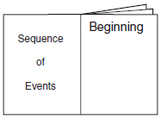  This foldable is perfect for post reading skills application. Use the book to record text sequence (first, next, last) or plot sequence (beginning, middle, end). Try color coding each section so students can see the sequence clearly.  Children may wish to use this Foldable for publishing their own stories.  Grammar Application  Like the vocabulary strategy applications above, the accordion book can be used to collect and share grammar skills such as:  - Nouns  - Action verbs  - Adjectives  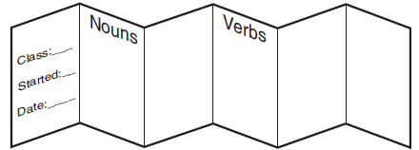 | Accordion Book Foldable Directions  Materials:  - Several sheets of 11” x 17” paper  - Glue  Directions:  - Fold each sheet of paper like a hamburger, but fold one side half an inch shorter than the other side. This will form a tab that is half an inch long.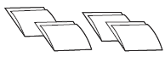  - Fold this tab forward over the shorter side, then fold it back away from the shorter piece of paper. (In other words, fold it the opposite way.)  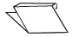  - To form an accordion, glue a straight edge of one section into the valley of another section’s tab.